K. J. Somaiya College of Engineering, Mumbai-77
(A Constituent College of Somaiya Vidyavihar University)


Batch: B3 Roll No.: 16010122158

Experiment No. 01

Grade: AA / AB / BB / BC / CC / CD /DD

Signature of the Staff In-charge with date

TITLE: Design the static web pages with the help of HTML5

AIM: Design the static web pages with the help of HTML5.
Example:
A) Design the following static web pages required for your WPL Mini Project
For Example Online Bookstore website.
1) HOME PAGE:
2) LOGIN PAGE:
3) CATOLOGUE PAGE: The catalogue page should contain the details of all the books available on the website in a table.
4) REGISTRATION PAGE
B) Create a table to show your class timetable.
______________________________________________________________________
Expected Outcome of Experiment: Design static web pages using various HTML tags.
________________________________________________________________
Books/ Journals/ Websites referred:

- w3schools.com
_____________________________________________________________________

Problem Statement:

Create Real Estate static web pages using HTML which has a login and registration page, home page and catalogue page.

HTML tags Used :

- style
- div
- a href
- h1
- h3
- h4
- img
- form
- nav
- br
- table

Description of the application implemented with output:

index.html:
<!DOCTYPE html>
<html>
<head>
<title>Real Estate</title>
<style>
a:link {
background-color: transparent;
text-decoration: none;
}

a:visited {
color: purple;
background-color: transparent;
text-decoration: none;
}

a:hover {
color: red;
background-color: transparent;
text-decoration: underline;
}

</style>

</head>
<body style="background-color:grey">
<div style="text-align:right">
<a href="login.html">Log-in</a>
<a href="signup.html">Sign-up</a>
</div>
<div style="text-align:center">
<nav>
<a href="index.html"><h1>Casa</h1></a>
<a href="buy.html"><h4>Browse Properties</h4></a>
</nav>
<br>
<div style="background-color:white">
<h3 style="color:maroon">Take a deep dive and browse homes for sale, original neighborhood photos, resident reviews and local insights to find what is right for you.</h3>
<h3>Learn the value of properties you're interested in by <a href="buy.html" style="underline:true">exploring homes</a>.</h3>
</div>
<img src="logo.png" alt="logo">
</div>
</body>
</html>

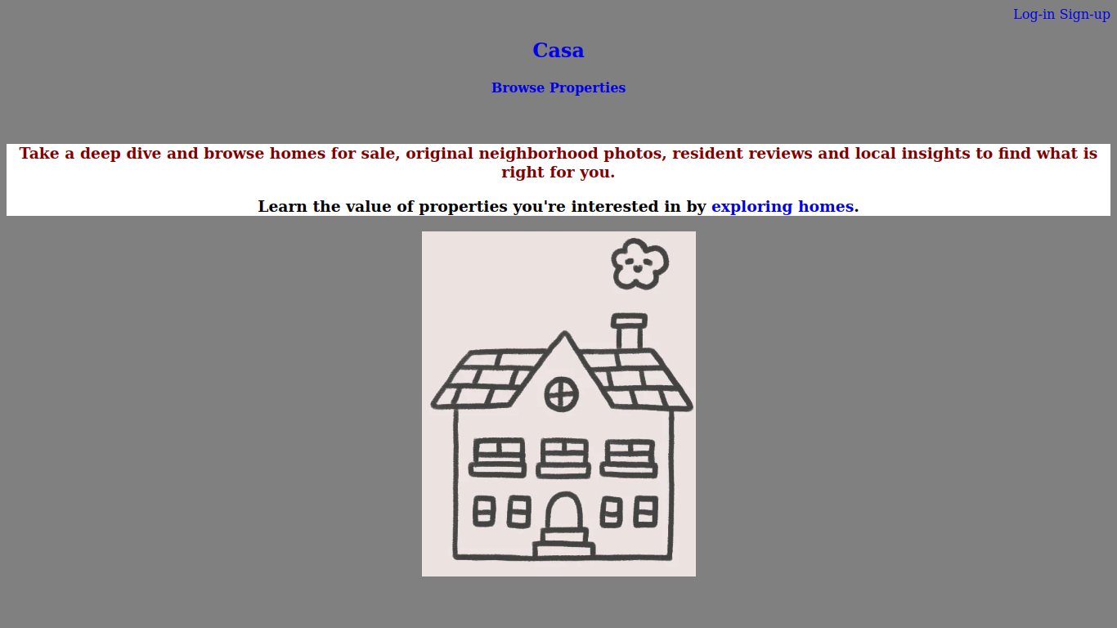

buy.html:
<!DOCTYPE html>
<html>
<head>
<title>Real Estate</title>
<style>
a:link {
background-color: transparent;
text-decoration: none;
}

a:visited {
color: purple;
background-color: transparent;
text-decoration: none;
}

a:hover {
color: red;
background-color: transparent;
text-decoration: underline;
}

.center {
margin-left: auto;
margin-right: auto;
}

table,
td {
border: 1px solid #333;
}

thead,
tfoot {
background-color: #333;
color: #fff;
}
</style>

</head>
<body style="background-color:grey">
<div style="text-align:right">
<a href="login.html">Log-in</a>
<a href="signup.html">Sign-up</a>
</div>
<div style="text-align:center">
<nav>
<a href="index.html"><h1>Casa</h1></a>
<a href="buy.html"><h4>Browse Properties</h4></a>
</nav>
<br>
<table class="center">
<thead>
<tr>
<th colspan="3">Available Properties</th>
</tr>
</thead>
<tbody>
<tr>
<td>Property 1</td>
<td>4000</td>
<td>3 bed ; 2 bath ; 1,568sqft ; 9.12 acre lot</td>
</tr>
<tr>
<td>Property 2</td>
<td>9400</td>
<td>4 bed ; 4 bath ; 4,000 sqft ; 8 acre lot</td>
</tr>
<tr>
<td>Property 3</td>
<td>8000</td>
<td>3 bed ; 3 bath ; 1,600 sqft ; 10 acre lot</td>
</tr>

</tbody>
</table>
</div>
</body>
</html>

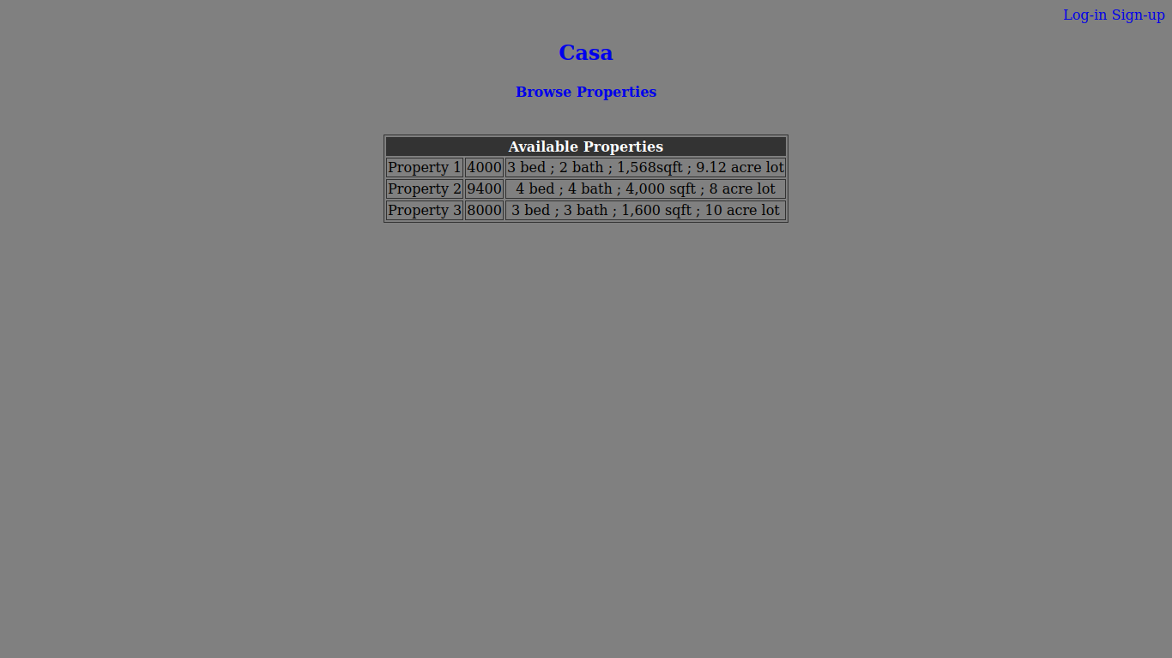
login.html:
<!DOCTYPE html>
<html>
<head>
<title>Real Estate</title>
<style>
a:link {
background-color: transparent;
text-decoration: none;
}

a:visited {
color: purple;
background-color: transparent;
text-decoration: none;
}

a:hover {
color: red;
background-color: transparent;
text-decoration: underline;
}

</style>

</head>
<body style="background-color:grey">
<div style="text-align:right">
<a href="login.html">Log-in</a>
<a href="signup.html">Sign-up</a>
</div>
<div style="text-align:center">
<nav>
<a href="index.html"><h1>Casa</h1></a>
<a href="buy.html"><h4>Browse Properties</h4></a>
</nav>
<br>
<form action="./index.html">
<label for="User-Id">User-Id:</label><br>
<input type="text" name="User-Id"><br>
<label for="Password">Password:</label><br>
<input type="password" name="Password"><br><br>
<input type="submit" value="Login">
</form>
</div>
</body>
</html>

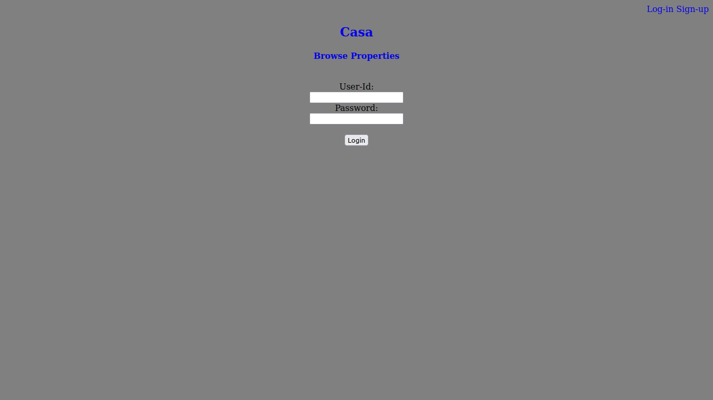
signup.html:
<!DOCTYPE html>
<html>
<head>
<title>Real Estate</title>

<style>
a:link {
background-color: transparent;
text-decoration: none;
}

a:visited {
color: purple;
background-color: transparent;
text-decoration: none;
}

a:hover {
color: red;
background-color: transparent;
text-decoration: underline;
}

</style>

</head>
<body style="background-color:grey">
<div style="text-align:right">
<a href="login.html">Log-in</a>
<a href="signup.html">Sign-up</a>
</div>
<div style="text-align:center">
<nav>
<a href="index.html"><h1>Casa</h1></a>
<a href="buy.html"><h4>Browse Properties</h4></a>
</nav>
<br>
<form action="./index.html" >
<label for="Fname">First Name:</label><br>
<input type="text" name="First Name"><br>
<label for="Lname">Last Name:</label><br>
<input type="text" name="Password"><br>
<label for="Gender">Gender:</label><br>
<label for="Male">Male</label>
<input type="radio" value="Male" name="Gender">
<label for="Female">Female</label>
<input type="radio" value="Female" name="Gender"><br>
<label for="Email">E-Mail:</label><br>
<input type="email" name="Email"><br>
<label for="Password">Password:</label><br>
<input type="password" name="Password"><br><br>
<input type="submit" value="Register">
</form> </div>
</body>
</html>

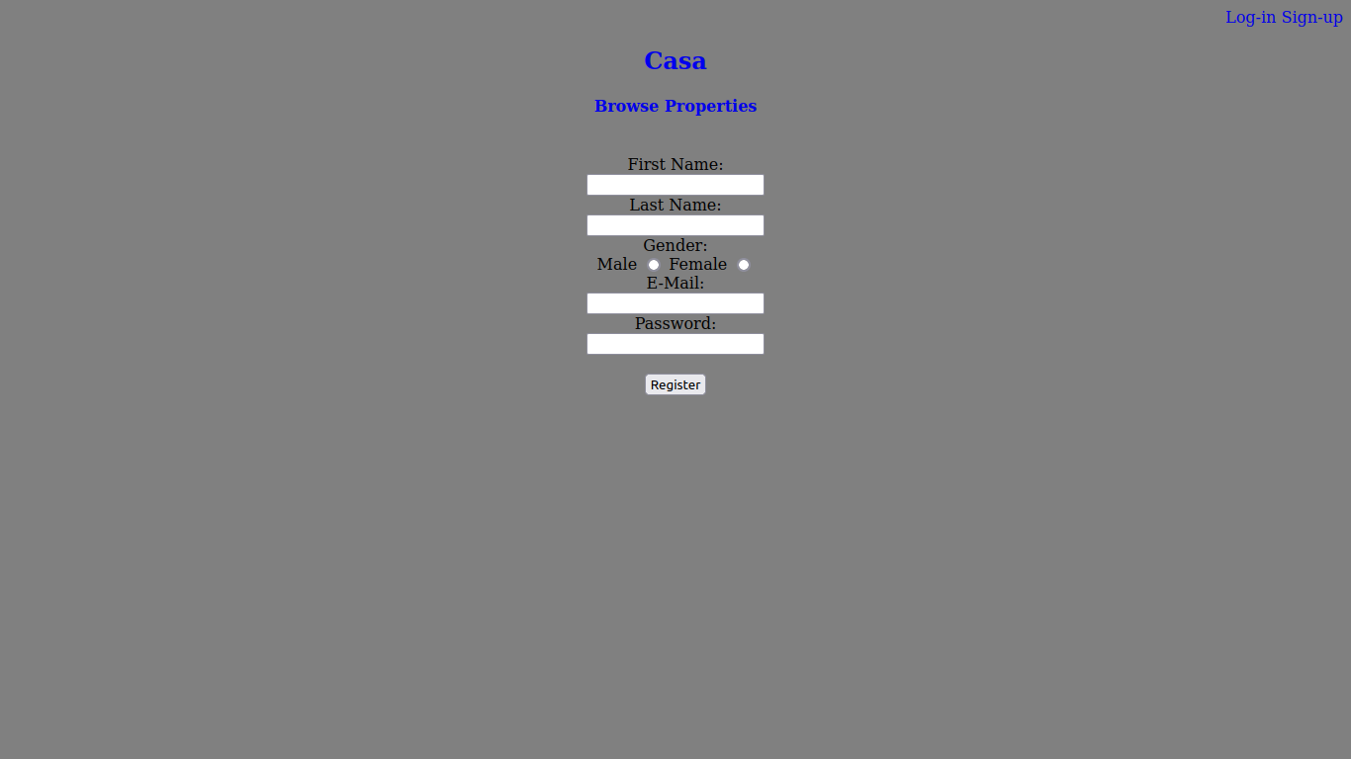
Post Lab Objective with Ans (Min 5):
The <style> tag was used to define the way the <href> tags look and behave - with them changing to red and underlined if hovered over.
<div> was used to divide the pages into different sections and apply separate alignments and colours to these divisions/sections in the pages.
<img> tag was used to display a placeholder picture in the home page.
<form>s were used along with <label>s and <input>s to make the layout of the sign up and login pages.
A <table> was used to display the available properties, their prices and some details.
Students need to mention and explain with syntax the tags used for problem statement they have selected.
Date: 22/01/2024 Signature of faculty in-charge

